**3.1 Insert records from 42_District_wise_crimes_committed_against_women_2001_2012.csv into a table**

* create table crime_against_womens(state text,district text,year int,rape int,kidnapping int, dowry_deaths int,assulting int,insult int,cruelty int,importation int);
* load data infile '42_District_wise_crimes_committed_against_women_2001_2012.csv' into table crime_against_womens

fields terminated by ','

ENCLOSED BY '"'

LINES TERMINATED BY '\n'

ignore 1 lines;

select * from crime_against_womens;

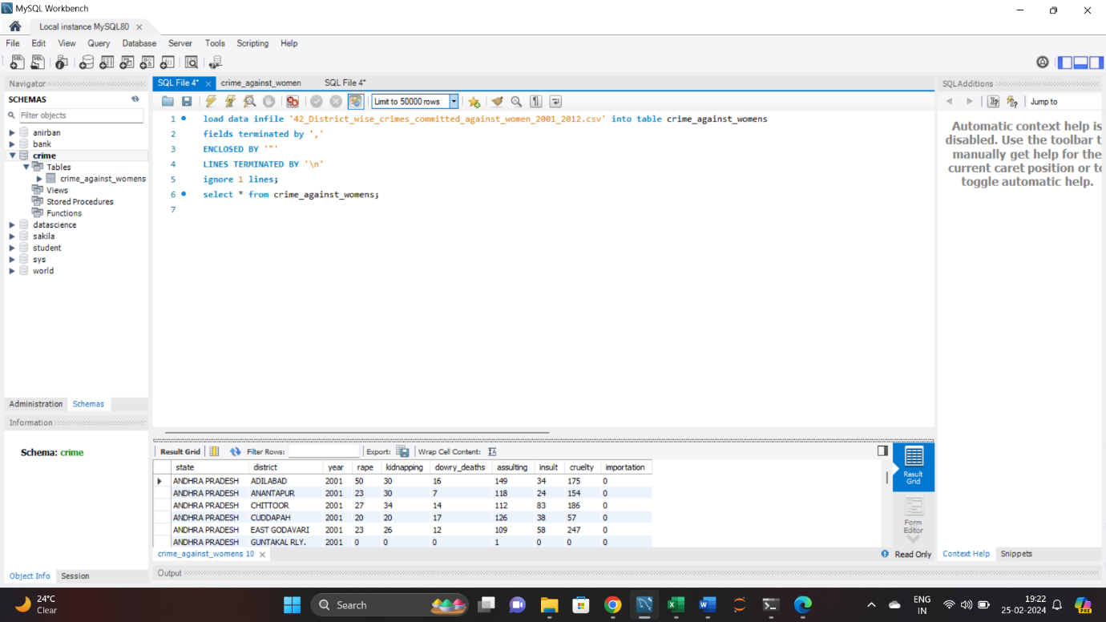

**3.2 Write SQL query to find the highest number of rapes & Kidnappings that happened in which state, District, and year**

* (select 'rape' as crime_type,state,district,year,max(rape) as max_crime from crime_against_womens where district != 'TOTAL' and district != 'DELHI UT TOTAL'

group by state, district, year

order by max_crime desc limit 1)

union

(select 'kidnapping' as crime_type,state,district,year,max(kidnapping) as max_crime from crime_against_womens where district != 'TOTAL' and district != 'DELHI UT TOTAL'

group by state, district, year

order by max_crime desc limit 1);

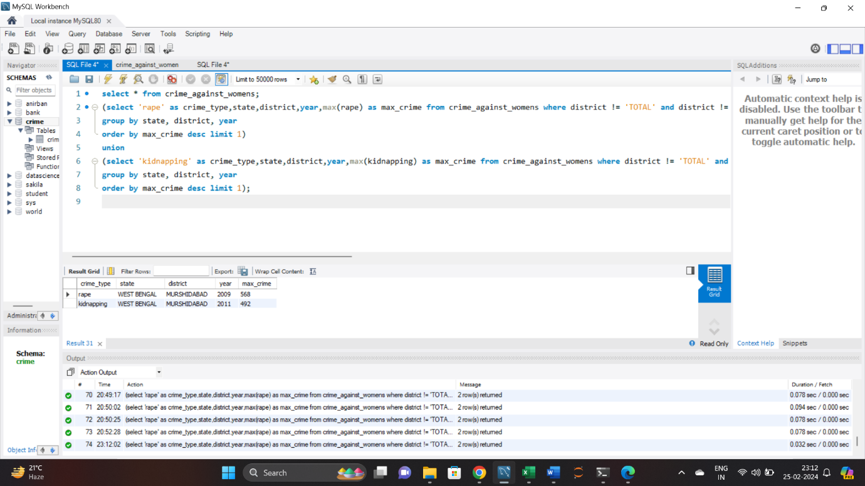

**3.3 Write SQL query to find All the lowest number of rapes & Kidnappings that happened in which state, District, and year**

* select 'rape' as crime_type, state, district, year, min(rape) as min_crime from crime_against_womens where district != 'TOTAL' and district != 'DELHI UT TOTAL'

group by state, district, year

union all

select 'kidnapping' as crime_type, state, district, year, min(kidnapping) as min_crime from crime_against_womens where district != 'TOTAL' and district != 'DELHI UT TOTAL'

group by state, district, year

order by min_crime;

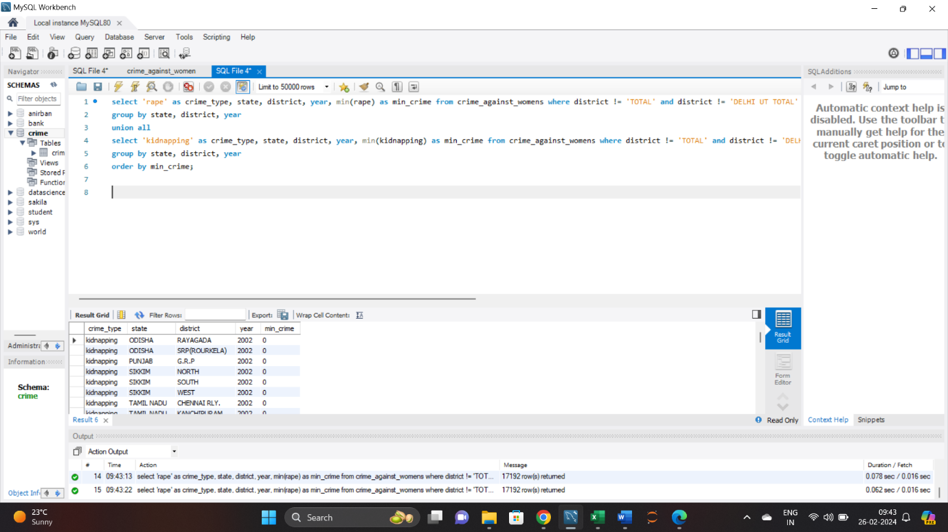

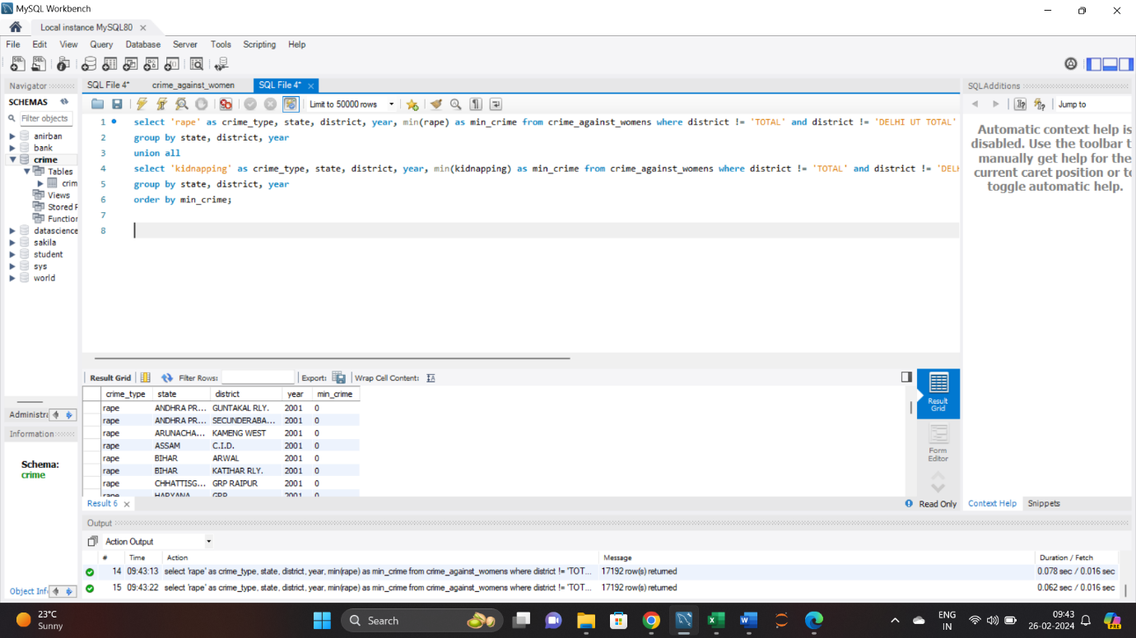

**3.4 Insert records from 02_District_wise_crimes_committed_against_ST_2001_2012.csv into a new table**

* create table crime_against_st

(state text,district text,year int,murder int,rape int,kidnapping int, dacoity int,robbery int,arson int,hurt int,pcr int,poa int,other int);

select * from crime_against_st

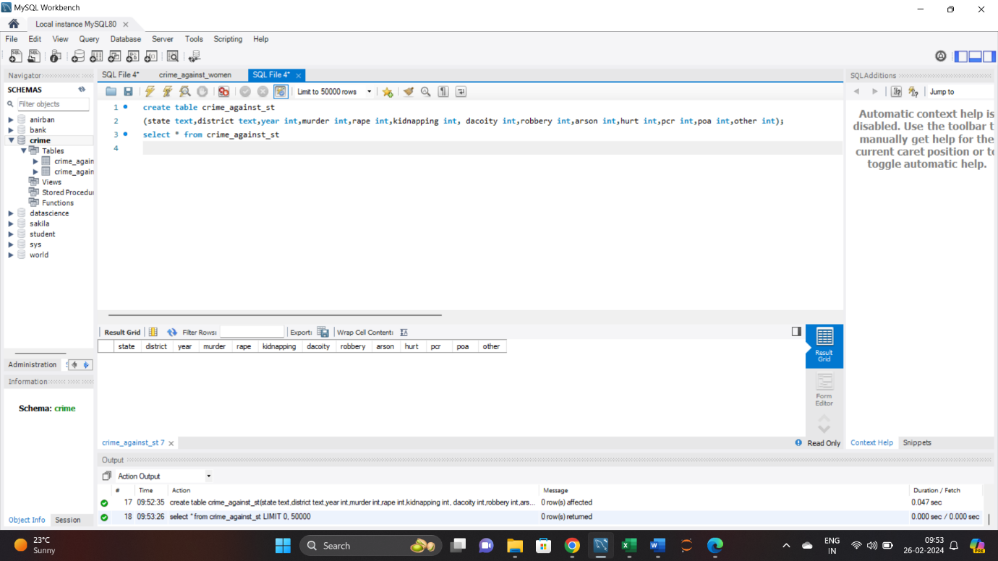

* load data infile '02_District_wise_crimes_committed_against_ST_2001_2012.csv' into table crime_against_st

fields terminated by ','

ENCLOSED BY '"'

LINES TERMINATED BY '\n'

ignore 1 lines;

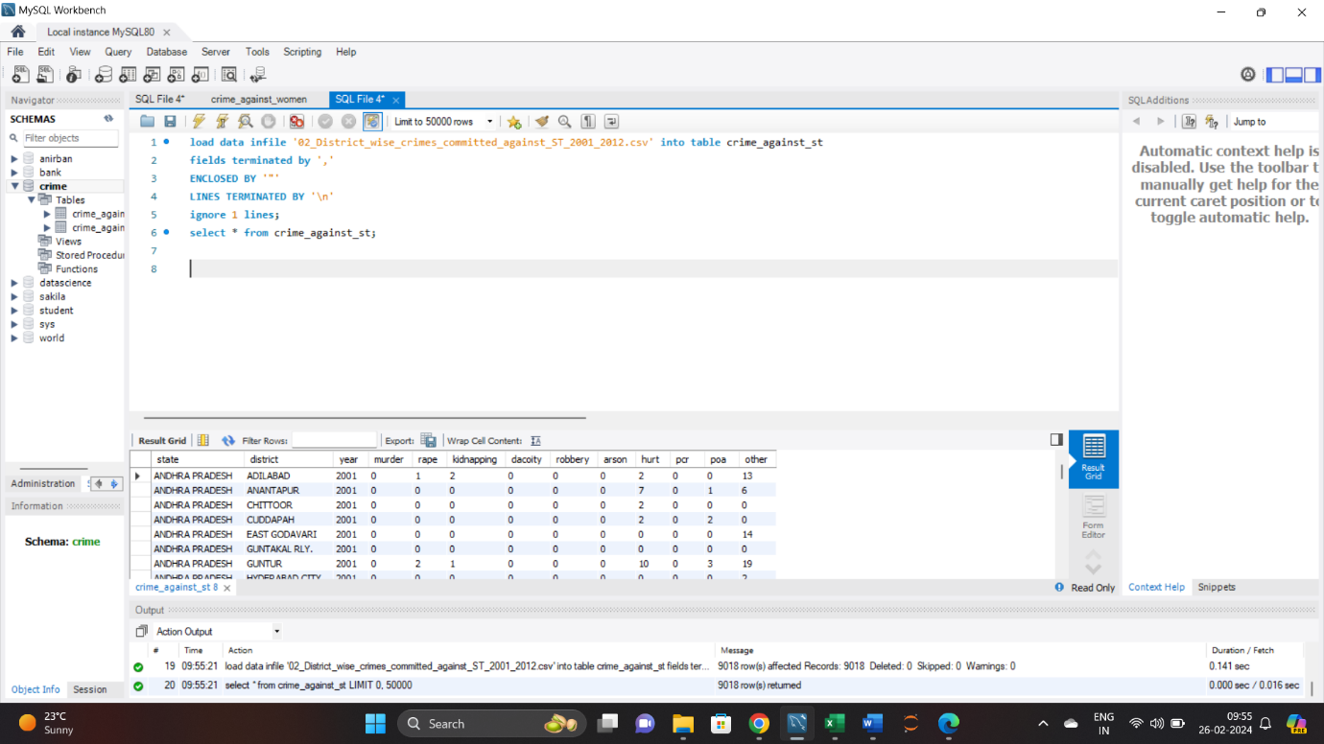

**3.5 Write SQL query to find the highest number of dacoity/robbery in which district.**

* (select 'dacoity' as crime_type,state,district,year,max(dacoity) as max_crime from crime_against_st

group by state, district, year

order by max_crime desc limit 1)

union

(select 'robbery' as crime_type,state,district,year,max(robbery) as max_crime from crime_against_st

group by state, district, year

order by max_crime desc limit 1);

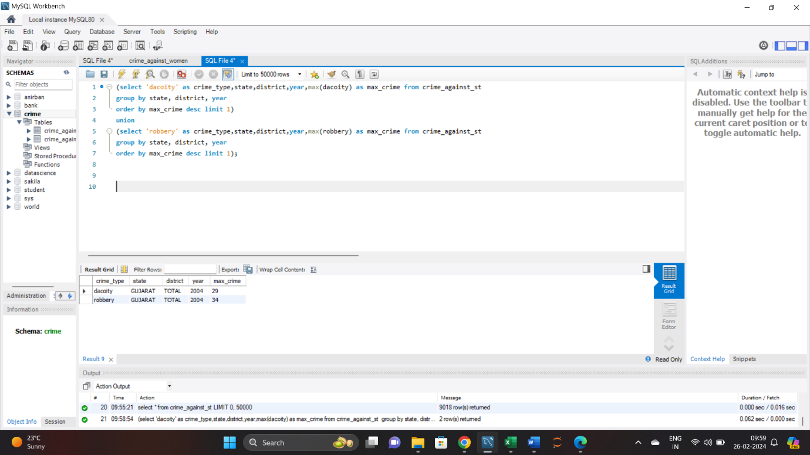

**3.6 Write SQL query to find in which districts(All) the lowest number of murders happened**

* select state,district,murder from crime_against_st where murder =(select min(murder) from crime_against_st);

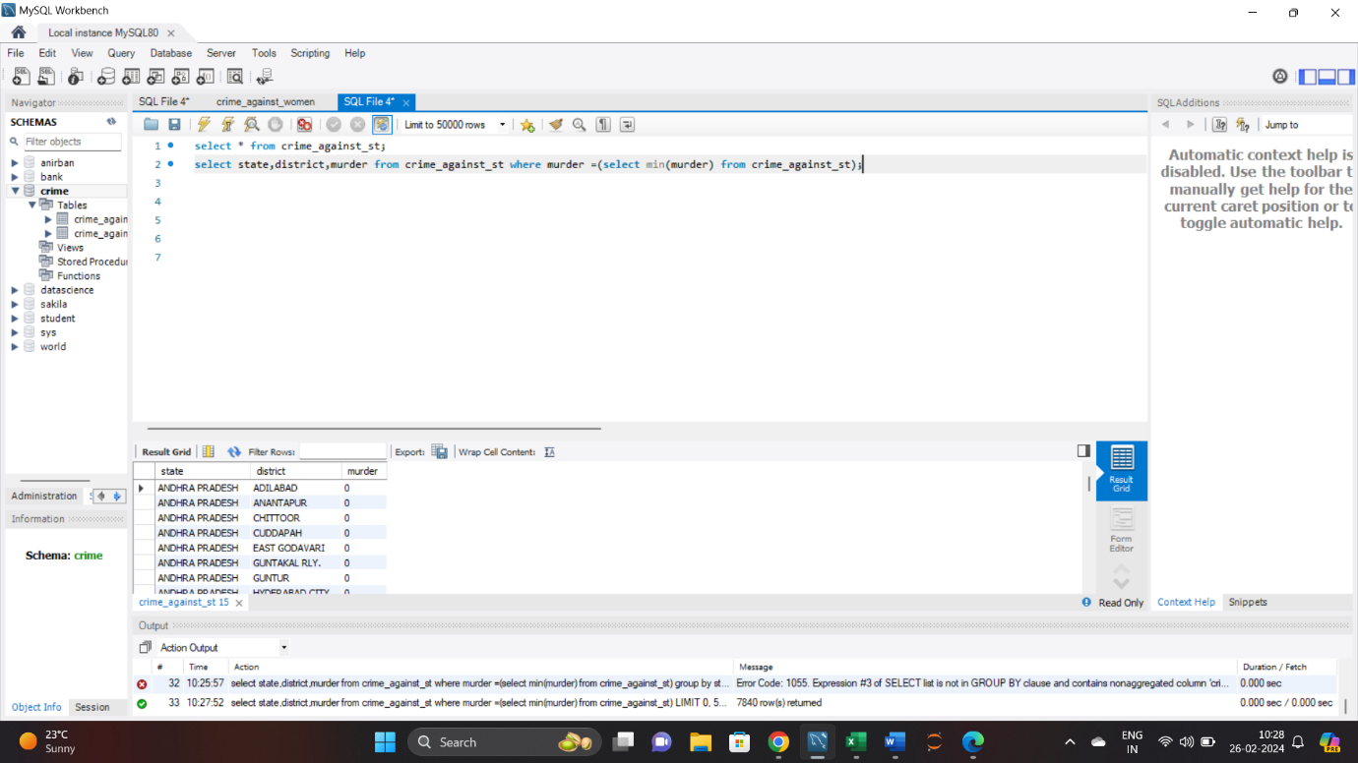

**3.7 Write SQL query to find the number of murders in ascending order in district and yearwise.**

* select state,district, year, murder

from crime_against_st

order by murder, year, district,state;

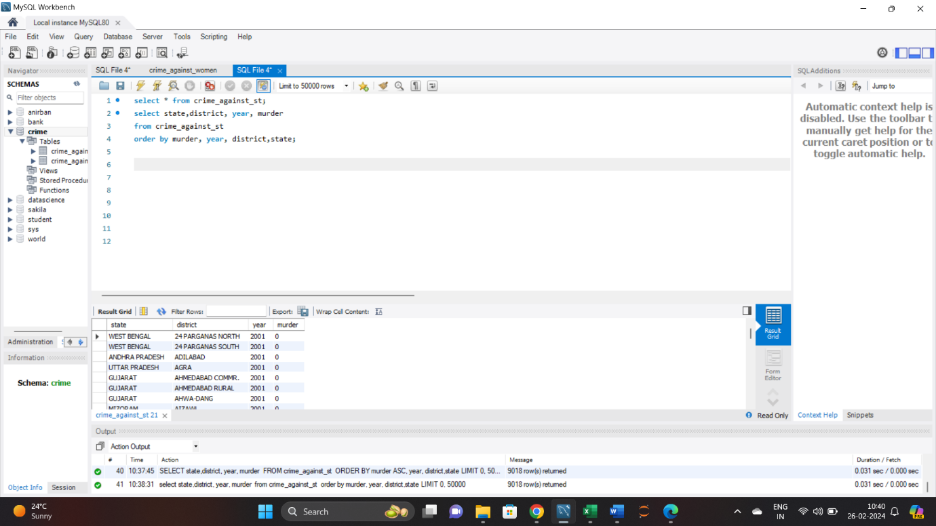

**3.8.1 Insert records of STATE/UT, DISTRICT, YEAR, MURDER, ATTEMPT TO MURDER, and RAPE columns only from 01_District_wise_crimes_committed_IPC_2001_2012.csv into a new table**

* create table crime_ipc(state text,district text,year int,murder int,attempt_to_murder int,rape int);
* LOAD DATA INFILE '01_District_wise_crimes_committed_IPC_2001_2012.csv'

INTO TABLE crime_ipc

FIELDS TERMINATED BY ','

LINES TERMINATED BY '\n'

ignore 1 lines;

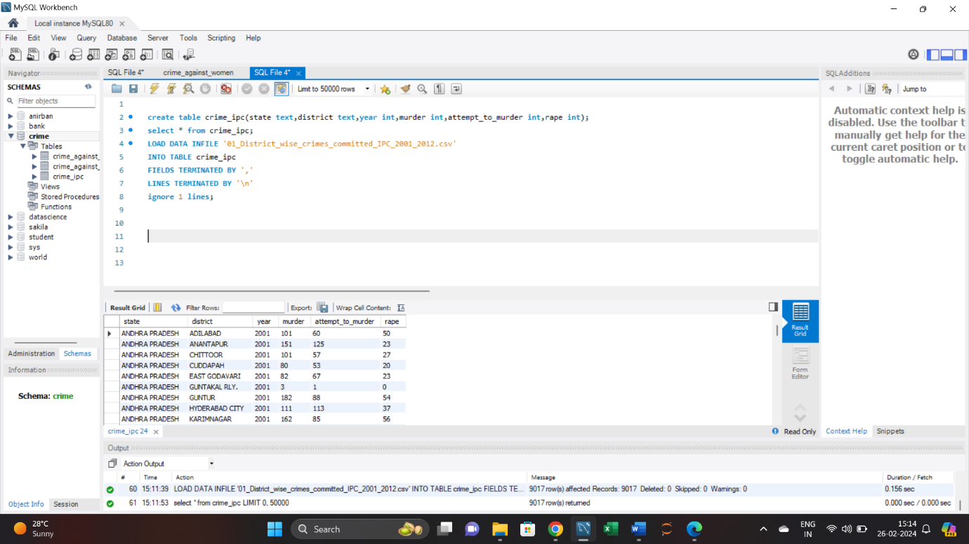

**3.8.2 Write SQL query to find which District in each state/ut has the highest number of murders yearwise. Your output should show STATE/UT, YEAR, DISTRICT, and MURDERS.**

* select state,district, year, max(murder) as max_murder

from crime_ipc where district != 'TOTAL' and district != 'DELHI UT TOTAL'

group by state,district,year

order by max_murder desc;

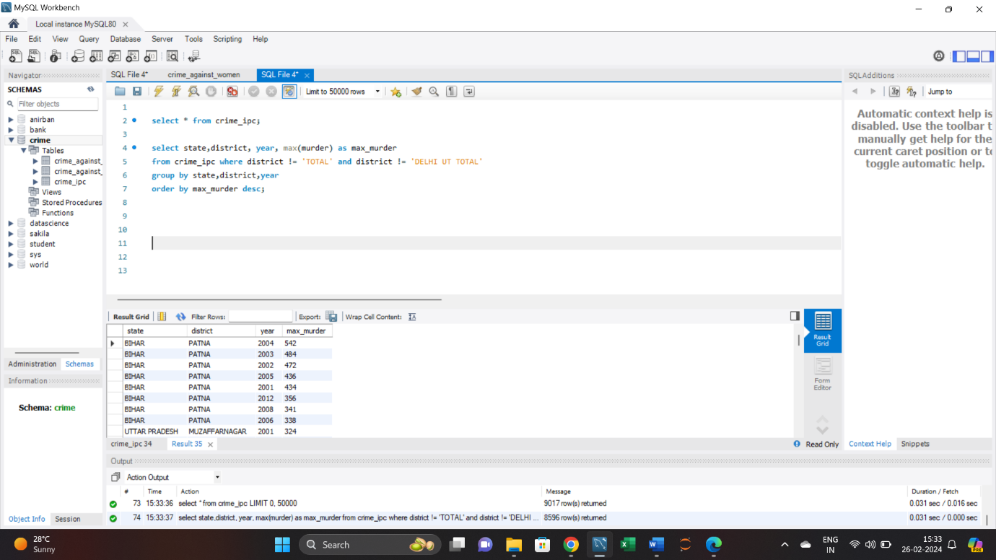

**3.8.3 Store the above data (the result of 3.8.2) in DataFrame and analyze districts that appear 3 or more than 3 years and print the corresponding state/ut, district, murders, and year in descending order.**

GitHub link - <https://github.com/anirbanranagalaxy/CapstoneProject/blob/main/Phase3.ipynb>